To reach a large group of high school students, an educational symposium on “Materials Discovery in Science and Engineering” was planned in collaboration with the Johns Hopkins University Center for Talented Youth. This symposium took place on May 11, 2019, with 100 students and parents hosted at UC Irvine. 13 faculty members were recruited from five different departments to give lectures. The topics ranged from “Nanomaterials for Phase Change Applications” to “Surprising things you can do with carbon: from trapping bed bugs to origami!” in order to build interest and excitement about a range of materials problems. Examples of student demonstrations are shown below, followed by the final program.

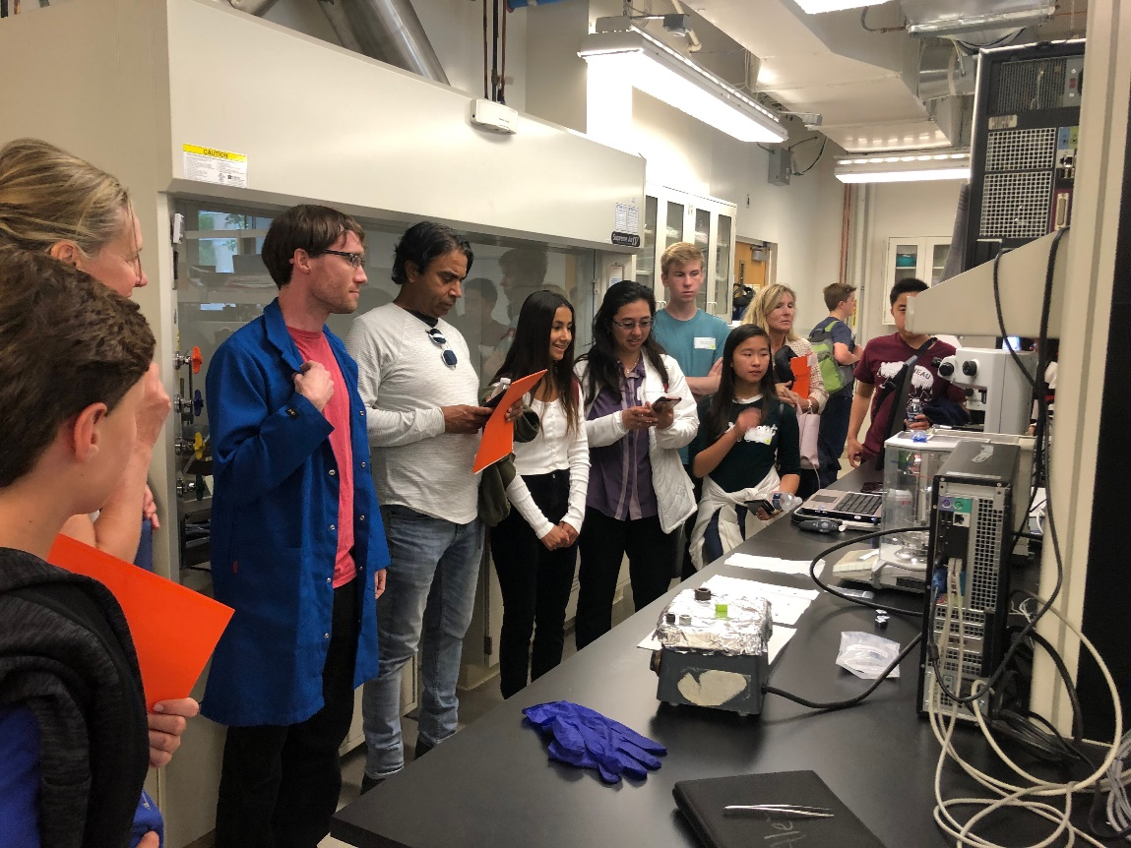
Figure 1. Students and parents learn about chemical analysis and microscopy from Dr. Alexander Dupuy, a postdoctoral scholar supervised by Prof. Julie Schoenung.

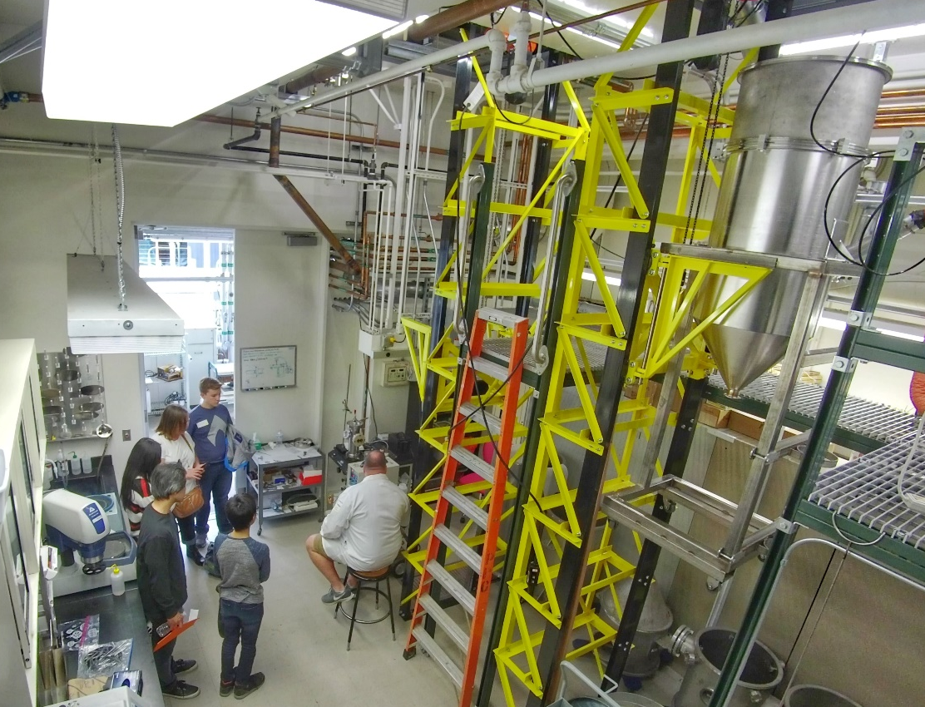
Figure 2. Students and parents observe equipment for the gas atomization of metallic powders.

Johns Hopkins Center for Talented Youth
Family Academic Programs

University of California, Irvine
Saturday, May 11, 2019

9:00 a.m. Check-In
Location: Social Sciences Plaza A (SSPA) 1100

9:30 a.m. Welcome and Opening Remarks
Location: SSPA 1100

Teri Miller
Family Academic Programs Representative
Johns Hopkins Center for Talented Youth

Tim Rupert, Ph.D.
Associate Professor
Department of Materials Science and Engineering
University of California, Irvine

9:45 a.m. Session I
Please follow the schedule that corresponds with the group number on your nametag.

GROUP 1
Lab Tours
Location: Meet outside of SSPA 1100

“Detecting diseases using devices, probes, and imaging”
Jered Haun, Ph.D.
Assistant Professor
Department of Biomedical Engineering
University of California, Irvine

GROUPS 2 AND 3
“Surprising things you can do with carbon: from trapping bed bugs to origami!”
Location: SSPA 1100
Marc Madou, Ph.D.
Professor
Department of Mechanical and Aerospace Engineering
University of California, Irvine

GROUP 4
“Dirty Energy: the Electric World of Soil Microbes”
Location: SSPA 1165
Allon Hochbaum, Ph.D.
Assistant Professor
Department of Materials Science and Engineering
University of California, Irvine

10:45 a.m. Break and Transition Time

11:00 a.m. Session II
Please follow the schedule that corresponds with the group number on your nametag.

GROUP 1
“Quantitative Percussion Diagnostics: A new paradigm detecting fine cracks”
Location: SSPA 1165
James Earthman, Ph.D.
Professor
Department of Materials Science and Engineering
University of California, Irvine

GROUP 2
Lab Tours
Location: Meet outside of SSPA 1100

“Photographing atoms using electron microscopy”
William Bowman, Ph.D.
Assistant Professor
Department of Materials Science and Engineering
University of California, Irvine

GROUPS 3 and 4
“Atoms to Airplanes: Design and Manufacturing of Advanced Materials Systems for Aircraft Propulsion”
Location: SSPA 1100
Daniel Mumm, Ph.D.
Associate Professor
Department of Materials Science and Engineering
University of California, Irvine

12:00 p.m. Lunch
Location: TBD

1:00 p.m. Session III

GROUPS 1 and 2
“Advanced Materials for Addressing Infrastructure Challenges”
Location: SSPA 1100
Mo Li, Ph.D.
Assistant Professor
Department of Civil and Environmental Engineering
University of California, Irvine

GROUP 3
Lab Tours
Location: Meet outside of SSPA 1100

“Advanced manufacturing from rocket thrusters to blades: metals, lasers, and 3D printing”
Julie Schoenung, Ph.D.
Professor
Department of Materials Science and Engineering
University of California, Irvine

GROUP 4
“A tale of two types of metal: crystal and metallic glass”
Location: SSPA 1170
Penghui Cao, Ph.D.
Assistant Professor
Department of Mechanical and Aerospace Engineering
University of California, Irvine

2:00 p.m. Break and Transition Time

2:15 p.m. Session IV

GROUP 1
“Nano-Metallurgy: New Physics and Improved Properties”
Location: SSPA 1100
Tim Rupert, Ph.D.
Associate Professor
Department of Materials Science and Engineering
University of California, Irvine

GROUP 2
“Assembling Gold Nanoparticles into Optical Noses for Sniffing Antibiotic Resistant Bacteria”
Location: SSPA 1165
Regina Ragan, Ph.D.
Professor
Department of Materials Science and Engineering
University of California, Irvine

GROUP 3
“Nanomaterials for Phase Change Applications”
Location: SSPA 1170
Yoonjin Won, Ph.D.
Assistant Professor
Department of Mechanical and Aerospace Engineering
University of California, Irvine

GROUP 4
Lab Tours
Location: Meet outside of SSPA 1100

“Nano Thermal Energy Research (NTER)”
Jaeho Lee, Ph.D.
Assistant Professor
Department of Mechanical and Aerospace Engineering
University of California, Irvine

3:15 p.m. Break and Transition Time

3:30 p.m. Closing Remarks and Evaluations
Location: SSPA 1100

